**SWOT ANALYSIS**

**SWOT analysis is a key part of any business and strategic plan. SWOT stands for strengths, weaknesses, opportunities and threats where strengths and weaknesses are internal factors and opportunities and threats are external factors. A SWOT diagram analyzes a project or business venture by focusing on each of these factors it typically consists of four boxes one for each area but the exact shape may vary depending on the design. SWAT diagrams can be especially useful when trying to decide whether or not to embark on a certain venture or strategy by visualizing the pros and cons by clearly outlining all positives and negatives of a project. SWOT analysis makes it easier to decide how to move forward first you want to figure out how to build on the strengths of your organization. A SWOT analysis will help you identify the parts of your business that are doing well these are your critical success factors aspects of your business that are strong and give you a competitive advantage recognizing these assets will help you continue on at a high level and you will need to find ways to leverage and build upon these strengths to grow your business.**

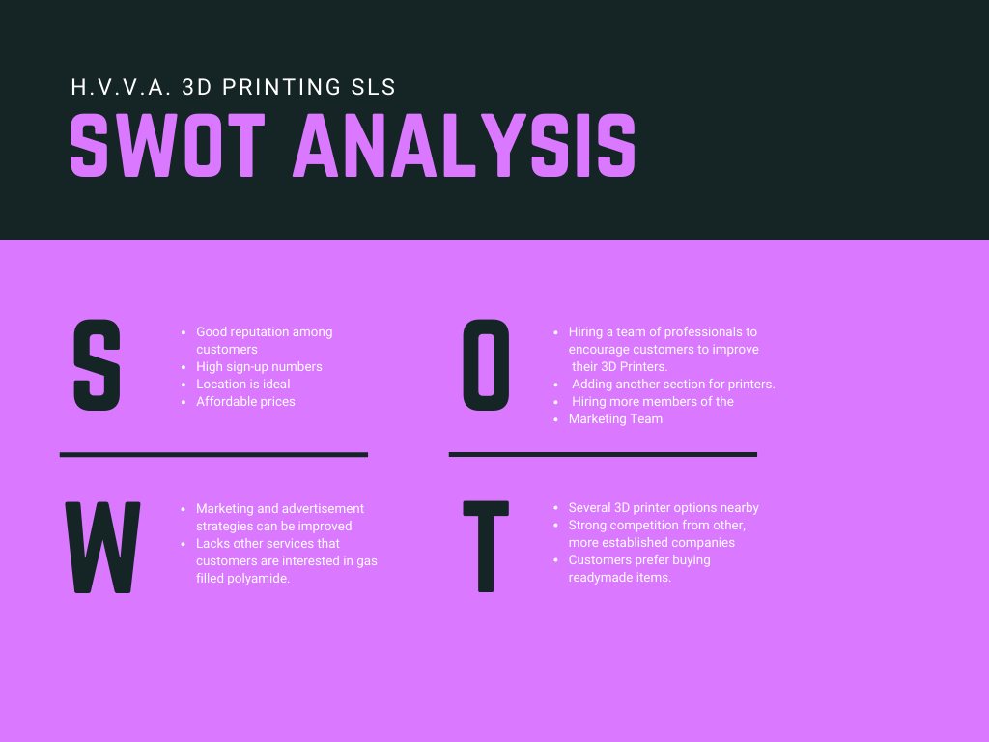

**FLOW FOR DYNAMIC 365**

**Image 1: We have created a lead by filling in the customer’s detail and then we need to qualify it to move further. We can also disqualify it on the basis of 4 things as mentioned in the given image.**

**Image 2: Our next step is to convert the lead into opportunity and at the bottom of the image you can clearly see the notification “Lead has successfully qualified” which means we have converted the lead into opportunity.**

**Image 3: Now, move to the Product Line items on the opportunity step itself and add the price list for the asked product and then choose system generated revenue to get the estimated revenue. Remember to check the currency always. After filling up all required material you can add product and finally you will get the estimated revenue of the product and then click on create quote.**

**Image 4: after creating quote you need to check all the details of the customer and then you can activate quote. You can also create a pdf of the quote and email it to the customer. Next step is to create invoice.**

**Image 5: After creating the invoice you can activate the invoice and check for the Invoice paid option and if the customer had paid the entire amount for the product select complete payment and finally you will get the status as paid. Invoice is the last step of the flow of dynamic.**

**Image 6: You can export all the date into excel sheet. In this image I have shown all the leads which can be exported into excel.**

**Image 7: At the last, you can see the visualization by going on the dashboards option and there you will see all the leads, opportunities, quotes, invoices, orders, etc. At the top of the page click on visual filter and then you can see the entire chart.**